**PRACTICAL 01**

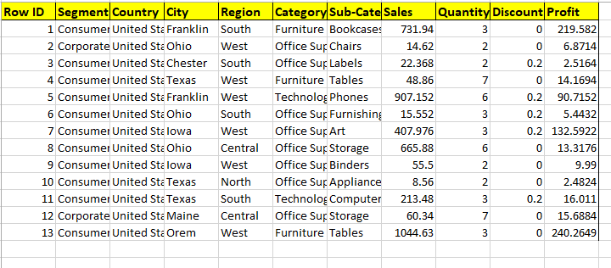

* The pie chart shows that the sales of sub-category **“Bookcases”** is more than any other sub-category product that means Bookcases is producing maximum profit.

**PROFIT BY SUB-CATEGORY**

* The column graph shows that the category **“Office Supplies”** is producing more profit that any other category of products.

**PROFIT BY CATEGORY**

* The line graph shows that the sales is maximum in **“Orem-west”** region than any other region.

**SALES BY REGION AND CITY**

* The column graph shows that **the profit due to sales of tables** is the maximum than any other category of products.

**PROFIT BY SALES AND CATEGORY**